**CONNECTING TO A DATABASE USING HIBERNATE**

1. **Create Persistent Class**: A persistent class in Hibernate is a Java class that represents an entity and is mapped to a database table.

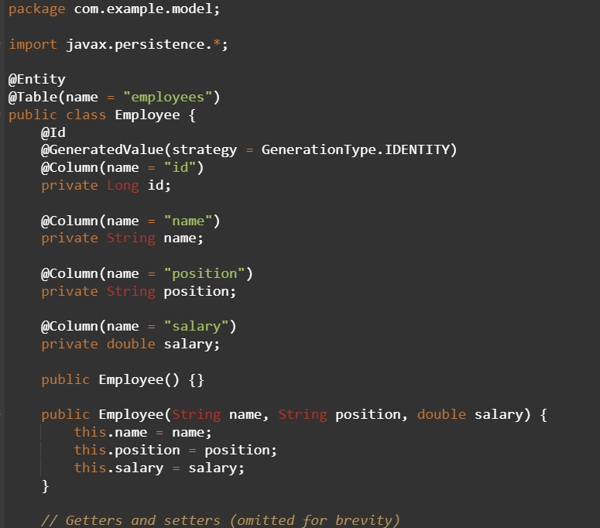

1. **Create the Mapping File for Persistent Class**: XML mapping files (*.hbm.xml) are often replaced by annotations directly on the entity class (@Entity, @Table, @Id, @Column). This simplifies the mapping process and reduces configuration overhead.
2. **Create the Configuration File**: The Hibernate configuration file (hibernate.cfg.xml) is essential for configuring Hibernate's session factory, which manages database connections and entity mappings.

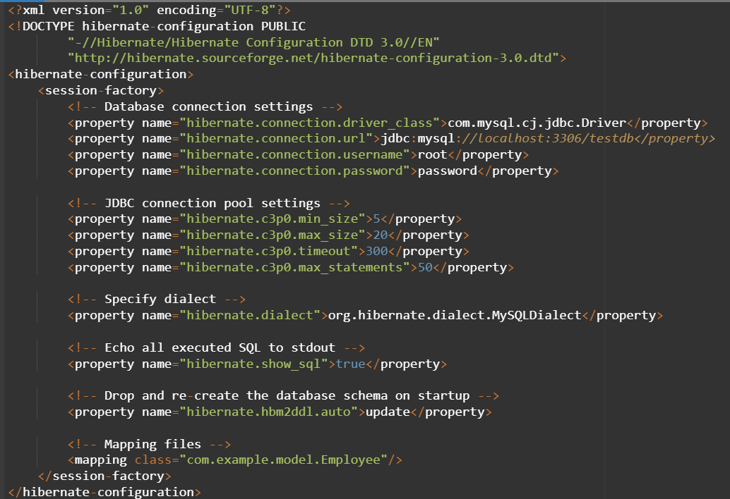

1. **Create the Class to Retrieve or Persist Objects**: This class (often referred to as DAO or Repository) encapsulates data access operations related to the Employee entity using Hibernate's session.

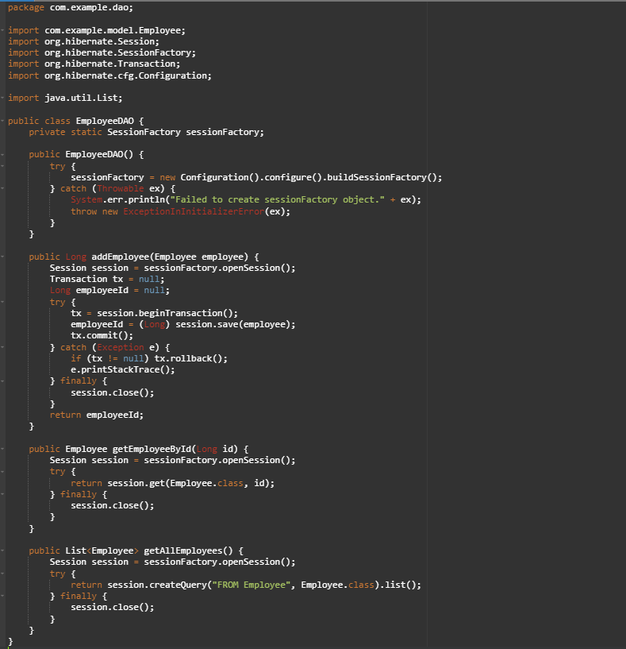

1. **Load the JAR files**: Ensure all necessary JAR files are included in your project's class path. This includes Hibernate core libraries JDBC driver for your database (e.g., MySQL Connector/J), and any other dependencies required by Hibernate.

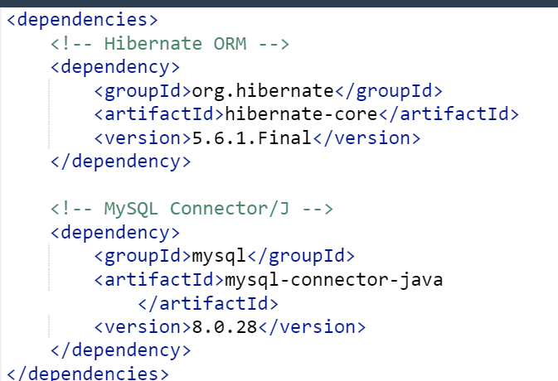

1. **Run the Application**: Execute the main class or entry point of your application to verify that all configurations, mappings, and database operations work correctly with Hibernate.

